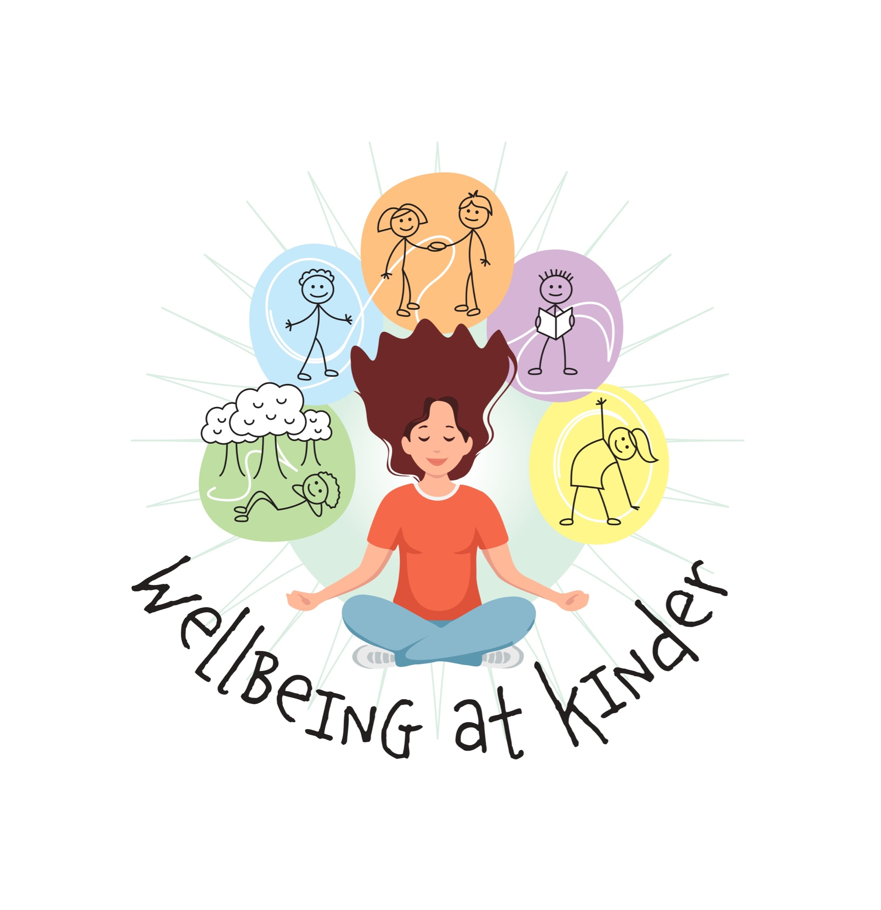
Teachers Mental Wellbeing
at Kinder
Erasmus+ Project
2022-1-PL01-KA220-SCH-000087191

Exercises for teachers
MINDFULNESS AND YOGA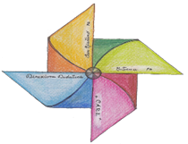Direzione Didattica “Francesca Turrini - Bufalini” San Giustino - Citerna (Italy)

Exercise 1 YOGA FIRST OF ALL BREATHE!

Objective of exercise: | Develop breathe awareness.  It teaches to deeply breathe to be quiet during lesson. It helps listen to your ownself.
Requirements and Duration: | 20 minutes.
Recording:
Source: ? | You can do the exercise before every lesson, in a quiet place: school, home before working day. The ideal should be stay barefoot on a gym carpet.
Description: | Starting from MOUNTAIN POSITION: it helps us to get our body as strong as a rock. It helps to blossom our mind for a present moment of being. Open slightly your legs. They must remain strong. Keep your arm along the body and palms touching thighs.
Reflection: | Do some breathe exercise. At every breathe, imagine to have a lace up your head, that gently pull upwards and straight your spine. When your exhale, contract and lift your pelvic muscles and squeeze your buttocks. Pull your navel in, towards your spine and feel the support you are providing to your lower back.  After having stretched your back well, rotate your palms forwards. Take a deep breath, raise your arms and join your hands above your head.  After a few minutes, exhaling slowly, lower your arms and hands in front of your face and then up to your chest, in accordance to your breathing.  Repeat the exercise at least 5 times.

Exercise 2: YOGA - LET THE STRESS GO AWAY!

Objective of exercise: | Let go and become aware of own body.
Requirements and Duration: | 15 minutes.
Recording:
Source: ? | “Roll down position”. It allows to own body let go, descarghing the stress accumulated tension and recover energy.  Do the exercise at home at the end of work day, or during a break. The important is stay in a quiet place.
Description: | Barefoot on a gym carpet stay in a mountain position.  Take a deep breath and stretch your spine upward. Get down your chin on your breast, you neck and your back with a “round moment”. Try to unroll your spine down as a pearl chain.
Reflection: | Hold your arms relaxed, slide your hands along the front of the thighs until the knees. If you can, try to stretch grazing towards the ground with your fingers. Don’t stress movements!  Let take some breathes, prepare to come back the the starting position. Breath in and exhale. Keep your back and your neck rounded, and your head swinging. Startin come slowly up, until you get back straight.  Repeat the exercise at least 3 times.

Exercise 3 YOGA: GROWING MOON POSITION (ANJANEYASANA)
Objective of exercise: | Stretch the spine; get better breath, it opens and get free the diaphragm ; get long front thigh muscles; bet rich balance, concentration and awareness of itself.
Requirements and Duration: | 20 minute.
Recording:
Source: ? | Barefoot on a gym carpet.
Description: | Standing up barefoot on a gym carpet. Let Have slowly movements, and go down. One knee is on the ground and the other is up. Stretch your body and your arms up with your palms touching. Keep your head line between your arms. After 20 seconds, come slowly back to the starting position.  Repeat the exercise almost 3 times.
Reflection: | Balance, concentration and awareness of itself.
Exercise 4: YOGA - HAPPY CHILD POSITION (ANANDA BALASANA)

Objective of exercise: | Get line spine, massage internal organs; get flexible legs, reduce physical and psychological stress.
Requirements and Duration: | 15 minutes.
Recording:
Source: ?
Description: | Standing up barefoot on your gym carpet, slowly sit down and until lay down. Put your legs and your arms up. Let try to touch your toes with your fingers and slowly balance left and right. At the end in a very slowly way put your legs and your hands down and standing up as unroll.  Repeat the exercise for 3 times.
Reflection: | It helps to become and to be more quite and go away stressful mind.

Exercise 5: YOGA - COW POSITION - BATILASANA -

Objective of exercise: | Get high flexibility of spine; get better coordination and position; get strong: abdominals and heart muscles arms, shoulders and wrists; reduce stress and Barefoot on a gym carpet, standing up, start to get down very slowly with your knees, your feet and hands palms touch the ground. To perform it , the practitioner comes very slowly down to the hands and knees. The back arches deeply, while the chest pushes outward and the head leans back. All this for 20 seconds. Before starting again, come back to the starting position in a very slowly and sweet movements.  Repeat the exercise three times.  and quiet mind.
Requirements and Duration: | 15 minutes.
Recording:
Source: ? | Barefoot, gym carpet.
Description: | Barefoot on a gym carpet, standing up, start to get down very slowly with your knees, your feet and hands palms touch the ground. To perform it , the practitioner comes very slowly down to the hands and knees. The back arches deeply, while the chest pushes outward and the head leans back. All this for 20 seconds. Before starting again, come back to the starting position in a very slowly and sweet movements.  Repeat the exercise three times.
Reflection: | It helps to reduce stress as all yoga practices, get rich more agility, and sleepssness.

(and always remember about the disclaimer)

Funded by the European Union. Views and opinions expressed are however those of the author(s) only and do not necessarily reflect those of the European Union or the European Education and Culture Executive Agency (EACEA). Neither the European Union nor EACEA can be held responsible for them.

